[How to Enable FTP Passive Mode](https://documentation.cpanel.net/display/CKB/How+to+Enable+FTP+Passive+Mode)

[Skip to end of metadata](https://documentation.cpanel.net/display/CKB/How+to+Enable+FTP+Passive+Mode#page-metadata-end)

* Created by [Sync User](https://documentation.cpanel.net/display/~syncuser), last modified on [May 08, 2014](https://documentation.cpanel.net/pages/diffpagesbyversion.action?pageId=361904&selectedPageVersions=1&selectedPageVersions=2)

[Go to start of metadata](https://documentation.cpanel.net/display/CKB/How+to+Enable+FTP+Passive+Mode#page-metadata-start)

* [Overview](https://documentation.cpanel.net/display/CKB/How+to+Enable+FTP+Passive+Mode#HowtoEnableFTPPassiveMode-Overview)
* [How do I enable the passive port range for Pure-FTPd?](https://documentation.cpanel.net/display/CKB/How+to+Enable+FTP+Passive+Mode#HowtoEnableFTPPassiveMode-HowdoIenablethepassiveportrangeforPure-FTPd?)
* [How do I enable the passive port range for ProFTPd?](https://documentation.cpanel.net/display/CKB/How+to+Enable+FTP+Passive+Mode#HowtoEnableFTPPassiveMode-HowdoIenablethepassiveportrangeforProFTPd?)

Overview

File Transfer Protocol (FTP) has two modes that you can use for an FTP connection: *active* and *passive*.

In *active* mode, the FTP server responds to the connection attempt and returns a connection request from a different port to the FTP client. NAT configurations block this connection request.

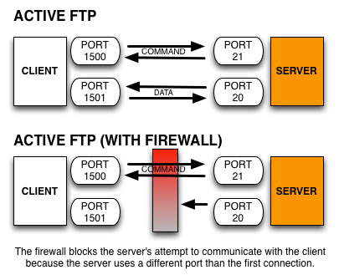

FTP's *passive* mode allows the FTP client to initiate both connection attempts. NAT configurations do not block this connection request.

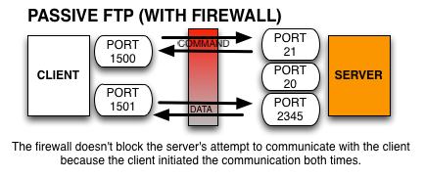

If you have FTP users within a NAT configuration, you **must** enable FTP's *passive* mode and open the passive port range in your FTP configuration file. You may also need to open the passive port range on your firewall.

How do I enable the passive port range for Pure-FTPd?

To enable the passive port range for Pure-FTPd, perform the following steps via the command line as the root user:

1. With your preferred text editor, open the /etc/pure-ftpd.conf configuration file.
2. Remove the comment (#) from the beginning of the line that contains the PassivePortRange option.
3. Set the PassivePortRange option so that it uses a port range that is greater than or equal to 1024.

In the following example, 30000:50000 is the PassivePortRange option:

|  |
| --- |
| PassivePortRange 30000 50000 |

**Important:**

Icon

We **strongly** recommend that you configure a large port range so that the server can process many simultaneous passive connections.  For example, 49152:65534 is the IANA-recommended port range.

1. Save the changes to the configuration file.
2. Run the /usr/local/cpanel/scripts/restartsrv_ftpserver command to restart the server.

Any system updates that you make may overwrite these configuration changes. To make these changes permanent, you will need to append the passive ports to the configuration file.  To do this, run the following command as the root user:

|  |
| --- |
| echo "PassivePortRange: 30000 50000" >> /var/cpanel/conf/pureftpd/main |

For more information on how to edit your Pure-FTPd configuration, read our [FTP FAQ](https://documentation.cpanel.net/display/ALD/FTP+FAQ).

How do I enable the passive port range for ProFTPd?

To enable the passive port range for ProFTPd, perform the following steps via the command line as the root user:

1. With your preferred text editor, open the /etc/proftpd.conf configuration file.
2. Add the following line to the first section of the configuration file:

|  |
| --- |
| PassivePortRange 30000 50000 |

1. Save the changes to the configuration file.
2. To restart the server, run the following command:

|  |
| --- |
| /usr/local/cpanel/scripts/restartsrv_ftpserver |

System updates may overwrite these configuration changes. To make these changes permanent, append the passive ports to the configuration file.  To do this, run the following command as the root user:

|  |
| --- |
| echo "PassivePorts: 30000 50000" >> /var/cpanel/conf/proftpd/main |

For more information on how to edit your Pro-FTPd configuration, read our [FTP FAQ](https://documentation.cpanel.net/display/ALD/FTP+FAQ).